**User Manual**

Project Title : Online Shop Management

Project Manager :

Dr. Kazi Masudul Alam Sir

Associate Professor

&

Dr. Manishankar Mondal Sir

Assistant Professor

Computer Science & Engineering Discipline

Khulna University

Khulna

Developed By :

Uttam Paul ID : 160236

Niloy Barman ID : 150237

Mahmud Hasan ID : 150239

Home Page

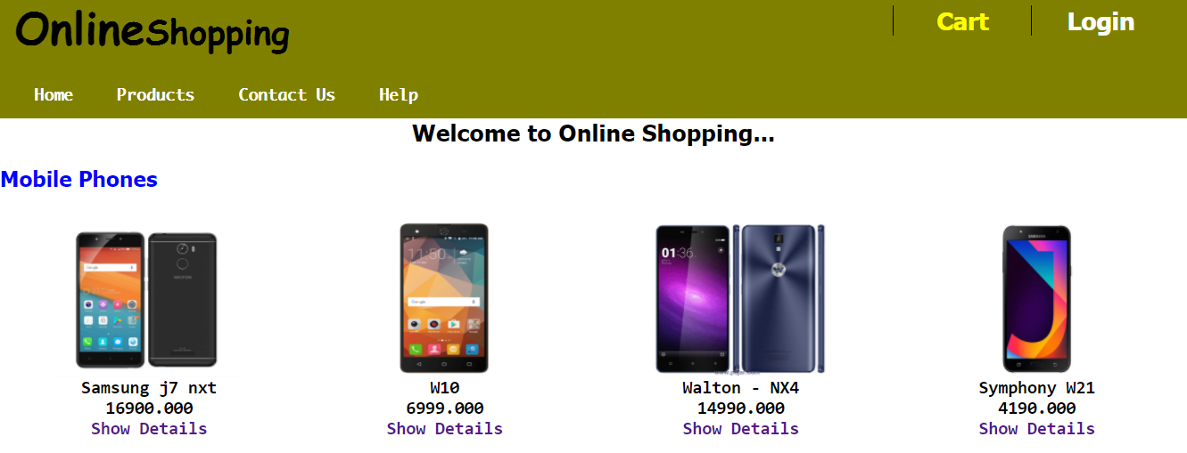

User can Cart any product

User can Log in

into the site

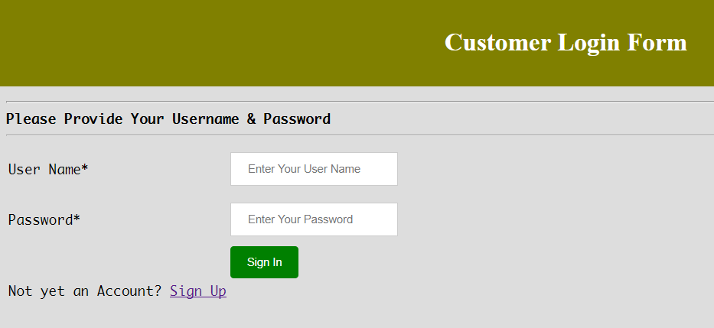

If not have an account user have to Sign Up here

Click the Sign in to log in

Fill the Password Field

Fill the User Name Field

Customer Registration Page

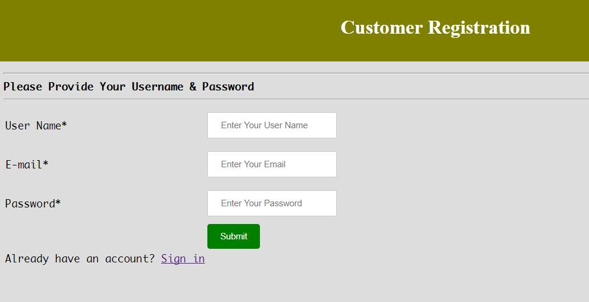

If have an account, Sign in Here

Click Submit

Fill the Password field

Fill the E-mail Field

Fill the User Name Field

Home Page (After Log In)

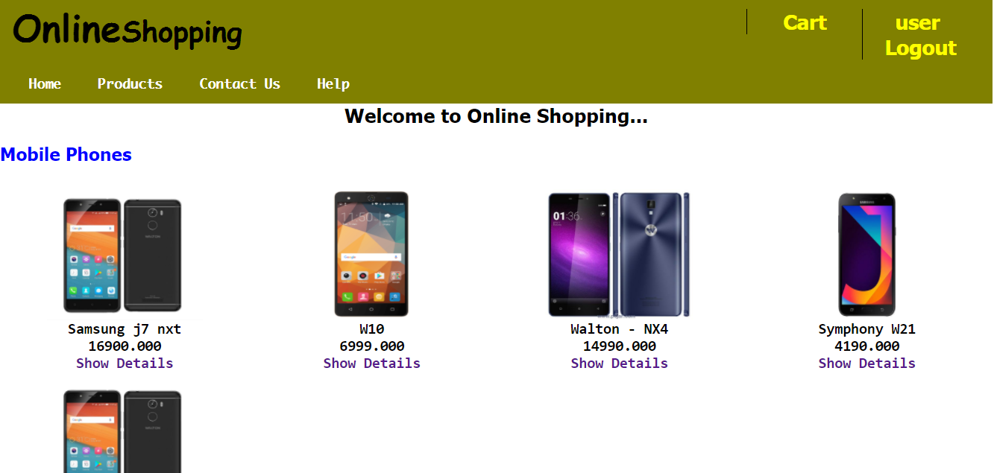

User’s User Name

Products Page

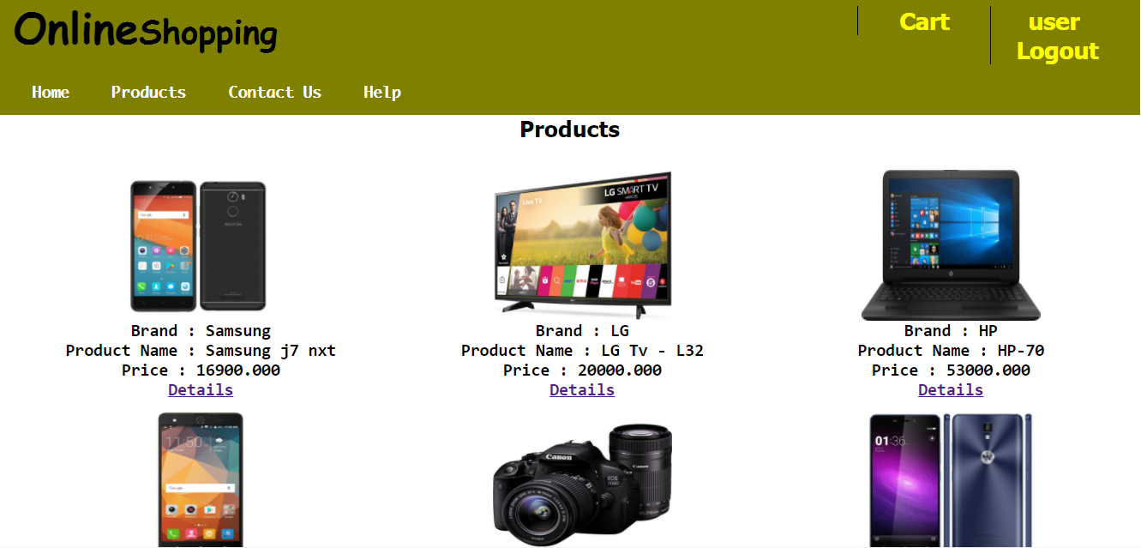

A list of Products

**View Details of a Product**

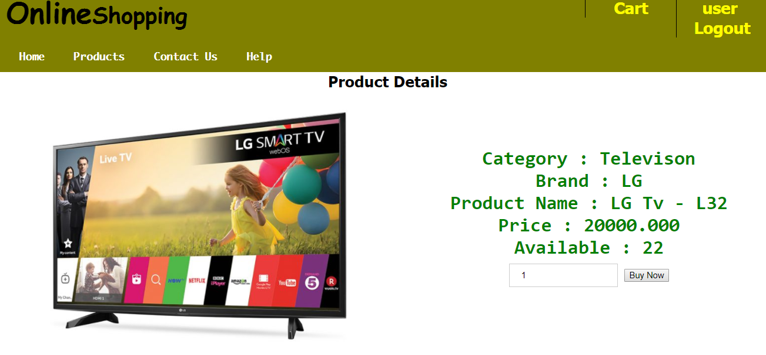

User can select a quantity & cart a product

Product Details

Cart Page

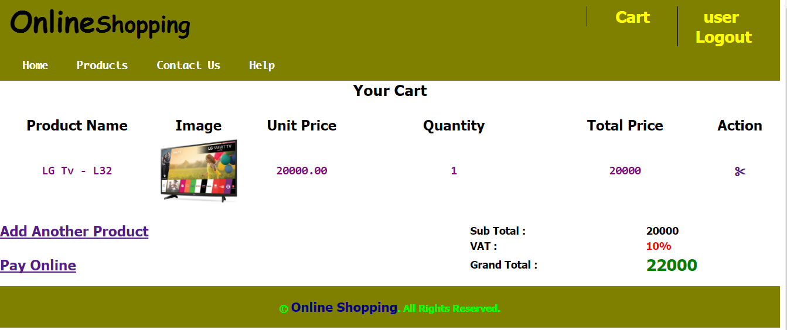

If user wants to buy another click here

Total Price

Total details of a product

If user wants to buy another click here

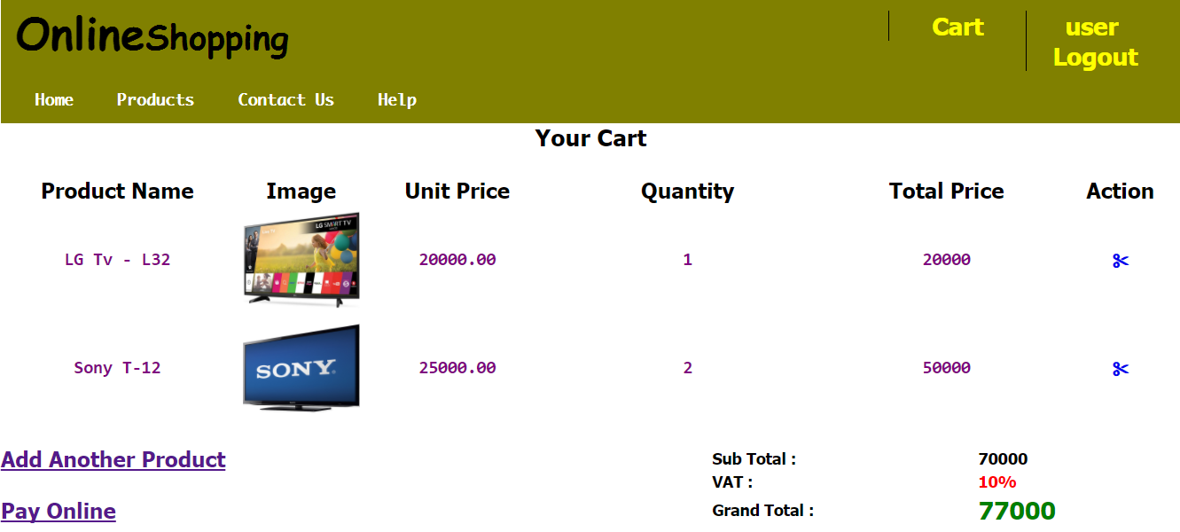

User cart another then it will show

Pay Online & Give the TN Number

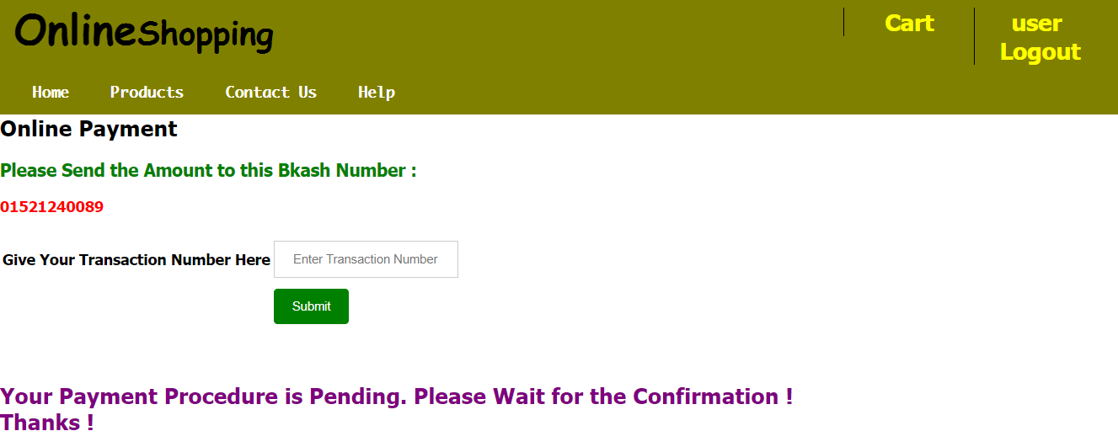

Pay money through bkash & give the TN number Here

Log in (Admin)

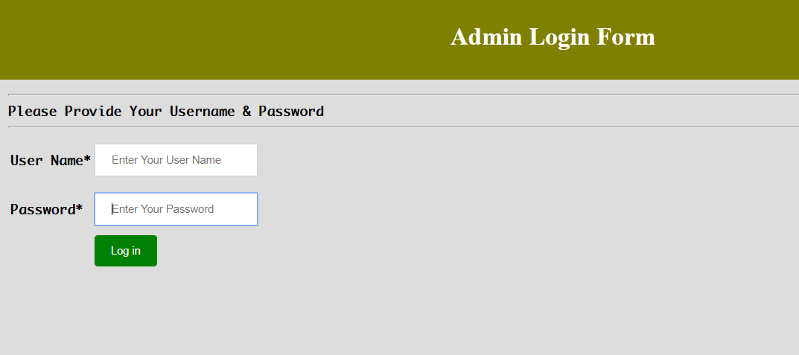

Admin will give the user name & password to log in to Dashboard

Add Category by Admin

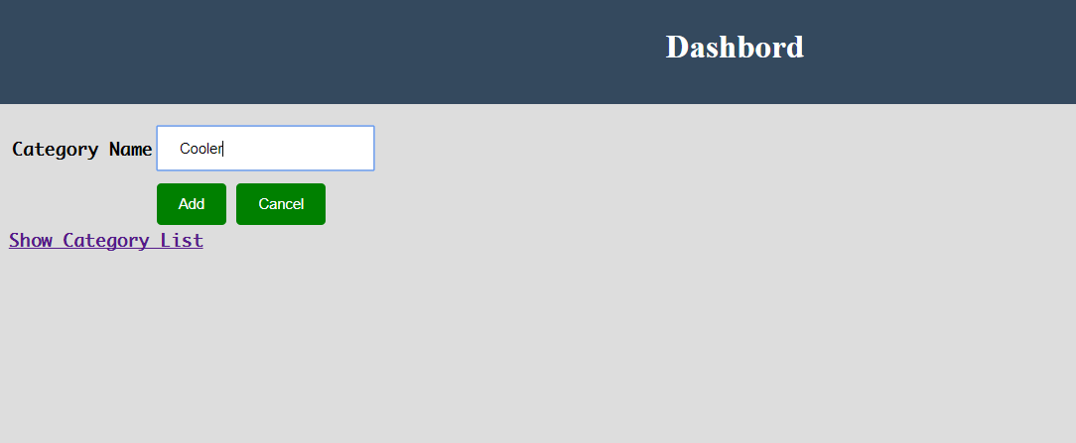

Admin fill a new category name & click add button

Added to the Category List

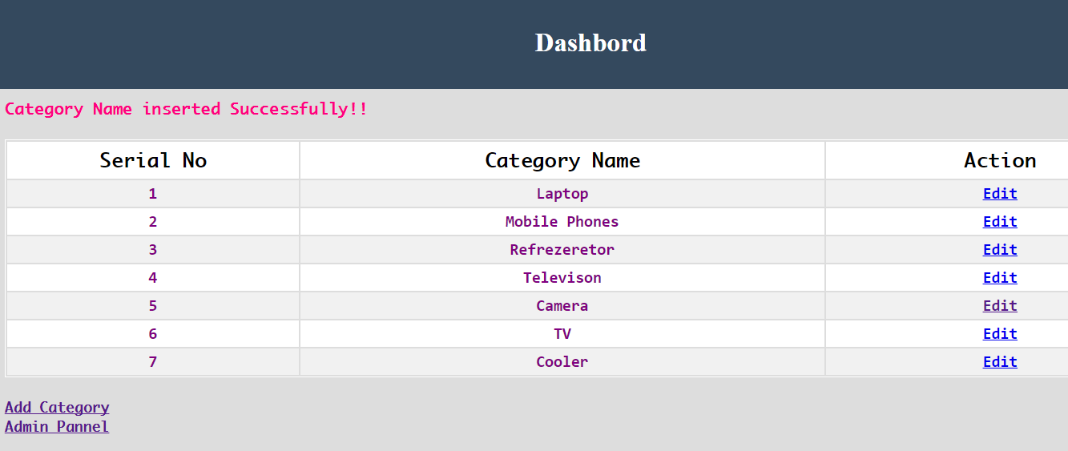

New Category “Cooler” added

Category Edit

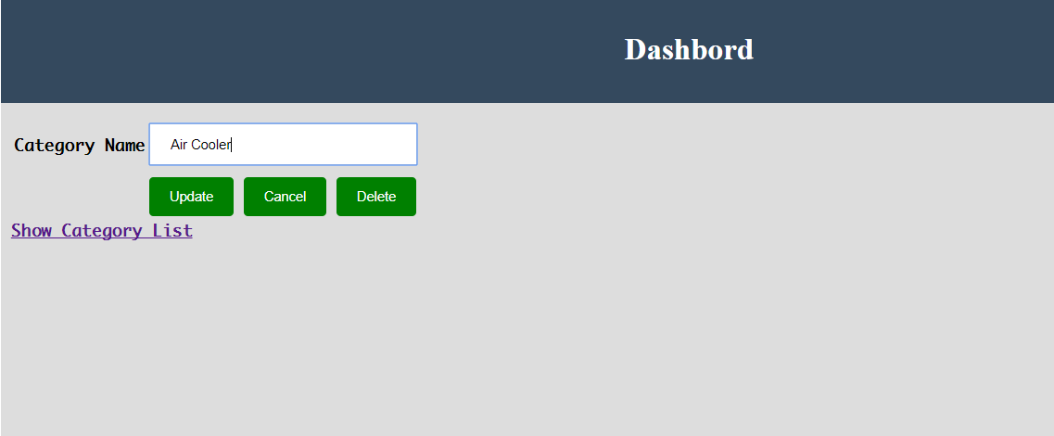

Edit ‘Cooler’ to ‘Air Cooler’

Category Update List

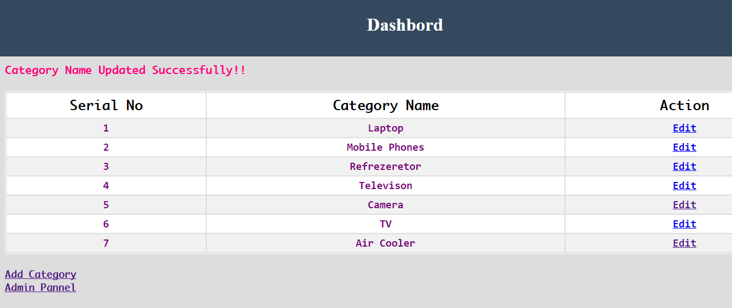

Cooler Updated to air cooler

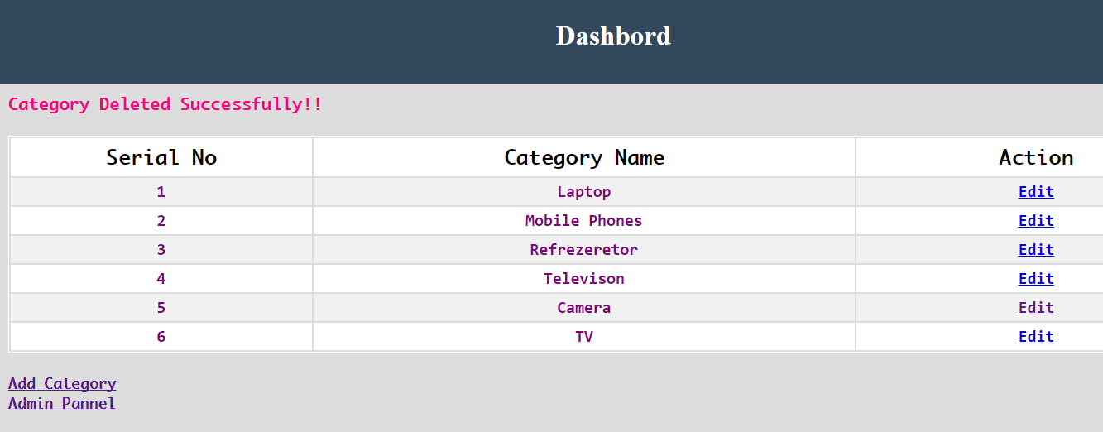

By clicking delete , category has deleted

Product Add

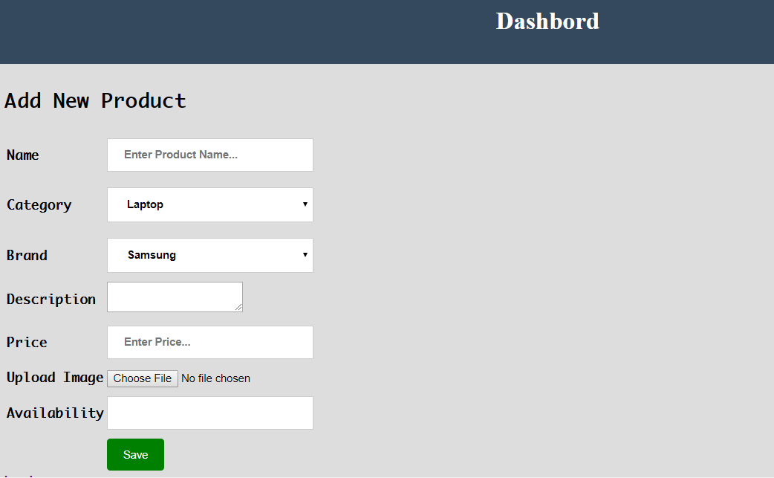

Adding the Product Name, Category, Brand, Description, Price, Image & availability field; A new Product will be created

Product List

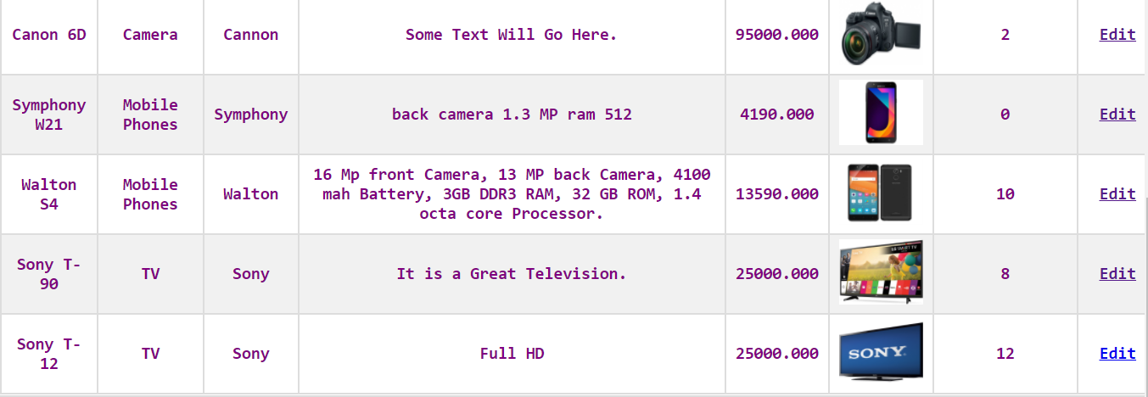

Admin Can Edit any Product if he wants